

Digital Board

Group:-

Abhishek khaiwale (205)

Siddharth kulkarni (213)

Rishav kumar (218)

Abhinav kumar (214)

Zeya khan (206)

Problem statement

Using Arduino and gsm module display a message or notice to some display device like LCD, and this message can be easily set or changed from anywhere in the world, just by using the **SMS facility** of your mobile handset.

Introduction

**Wireless notice board** has a very wide scope rather than just being a simple notice board. The purpose of this project is that in this system we can display a message or notice to some display device like LCD, and this message can be easily set or changed from anywhere in the world, just by using the **SMS facility** of your mobile handset.

This is very useful in Hotels, Malls, college, offices and can be used anywhere, even at home. Like you can set the message like “Do not disturb” at your hotel’s room gate, can set message at your home’s door step when you are away, and of course it is used as notice board in schools, colleges, cinema halls etc. And yes, it’s just not a simple Message board, the usefulness of this project is that you can set or change the message or notice from anywhere, just sending SMS from your phone

In this project, **Arduino UNO** is used for controlling the whole process, **GSM module (SIM800L)** to receive the SMS/message sent from mobile phone and **LCD** to display the message.

Circuit Diagram

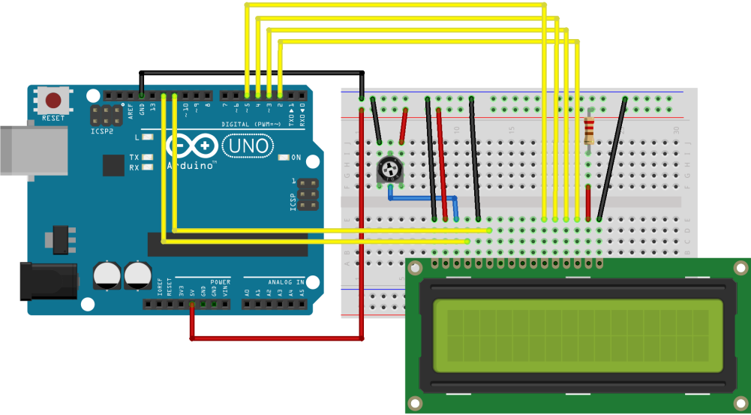

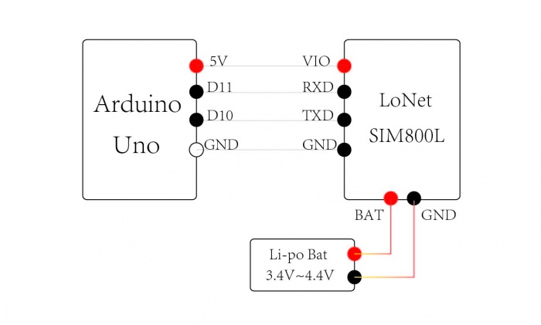

Project Picture

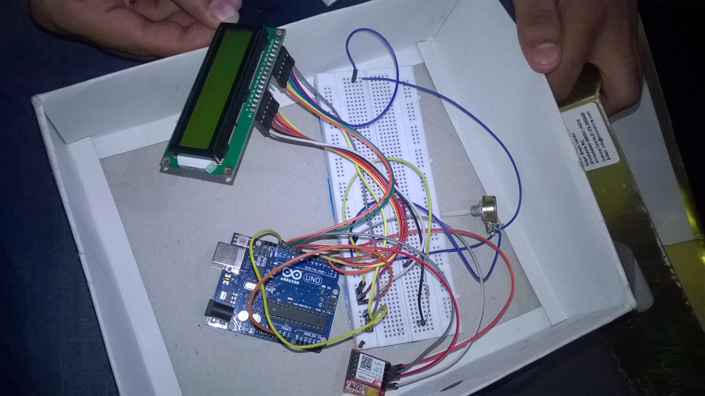

Data Capturing

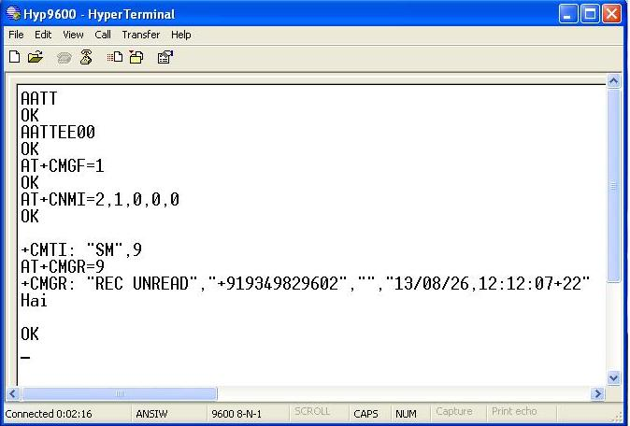

Data visualisation

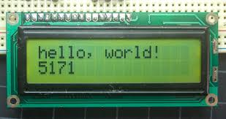

Conclusion

* We were successfully able to intergrate our arduino with gsm module and led screen.
* The digital board is working with a great response time.

Future work

* In future we will try to include voice notification we are also planning to get a compact veraion of this with a great design.
* This one currently works with a gsm module only. We will like to add many more features like wifi and bluetooth so save those data charges for sms.
* We will also work on security because as for now anyone can send a sms and display a notification on led but in the future version we can set some restriction on who can set those notifications on the led screen.

**Reference**

|  |
| --- |
| 1. G. O. Young, " structure of GSM module " 2nd ed., vol. 3, J. Peters, Ed. New York: McGraw-Hill, 1964, pp. 15-64. |
| 1. S. M. Hemmington, Aurdino uno Saskatoon: Univ. of Saskatchewan Press, 1997. |
| 1. Sarunyagate, “Arduno and GSM module” New York: McGraw-Hill, 1996. |